Experiment No. 1

1. Traversal (Display Array)
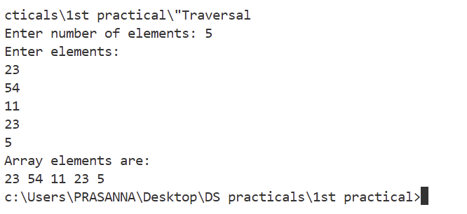
#include<stdio.h>
int main()
{
int arr[100], n, i;
printf("Enter number of elements: ");
scanf("%d",&n);
printf("Enter elements:\n");
for(i=0;i<n;i++)
scanf("%d",&arr[i]);
printf("Array elements are:\n");
for(i=0;i<n;i++)
printf("%d ",arr[i]);
return 0;
}

2. Insertion
#include<stdio.h>
int main()
{
int arr[100], n, i, pos, val;
printf("Enter number of elements: ");
scanf("%d",&n);
for(i=0;i<n;i++)
scanf("%d",&arr[i]);
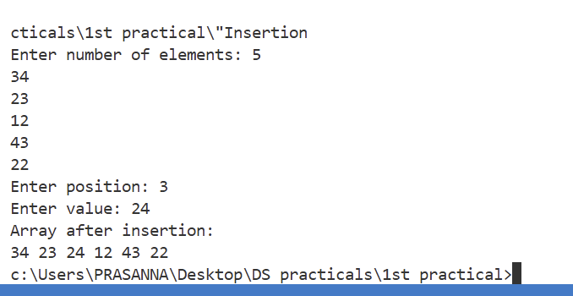
printf("Enter position: ");
scanf("%d",&pos);
printf("Enter value: ");
scanf("%d",&val);
for(i=n;i>=pos;i--)
arr[i]=arr[i-1];
arr[pos-1]=val;
n++;
printf("Array after insertion:\n");
for(i=0;i<n;i++)
printf("%d ",arr[i]);
return 0;
}

3. Deletion
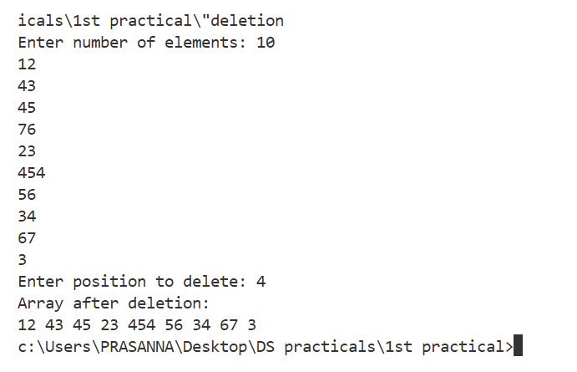
#include<stdio.h>
int main()
{
int arr[100], n, i, pos;
printf("Enter number of elements: ");
scanf("%d",&n);
for(i=0;i<n;i++)
scanf("%d",&arr[i]);
printf("Enter position to delete: ");
scanf("%d",&pos);
for(i=pos-1;i<n-1;i++)
arr[i]=arr[i+1];
n--;
printf("Array after deletion:\n");
for(i=0;i<n;i++)
printf("%d ",arr[i]);
return 0;
}

4. Searching (Linear Search)
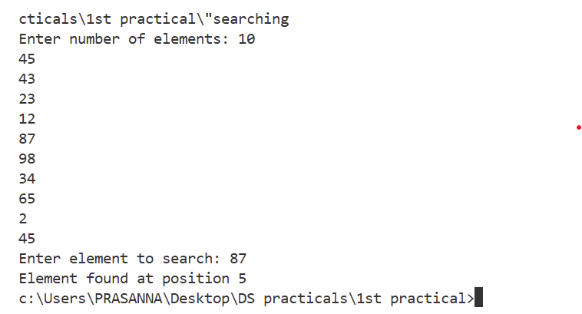
#include<stdio.h>
int main()
{
int arr[100], n, i, key, found=0;
printf("Enter number of elements: ");
scanf("%d",&n);
for(i=0;i<n;i++)
scanf("%d",&arr[i]);
printf("Enter element to search: ");
scanf("%d",&key);
for(i=0;i<n;i++)
{
if(arr[i]==key)
{
printf("Element found at position %d",i+1);
found=1;
break;
}
}
if(found==0)
printf("Element not found");
return 0;
}

5. Sorting (Ascending Order)
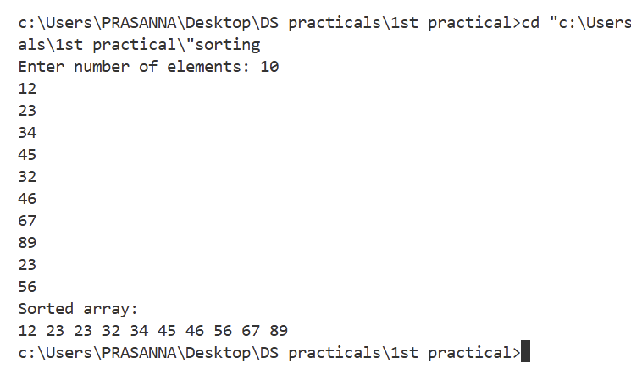
#include<stdio.h>
int main()
{
int arr[100], n, i, j, temp;
printf("Enter number of elements: ");
scanf("%d",&n);
for(i=0;i<n;i++)
scanf("%d",&arr[i]);
for(i=0;i<n-1;i++)
{
for(j=i+1;j<n;j++)
{
if(arr[i]>arr[j])
{
temp=arr[i];
arr[i]=arr[j];
arr[j]=temp;
}
}
}
printf("Sorted array:\n");
for(i=0;i<n;i++)
printf("%d ",arr[i]);
return 0;
}

6. Merging Two Arrays
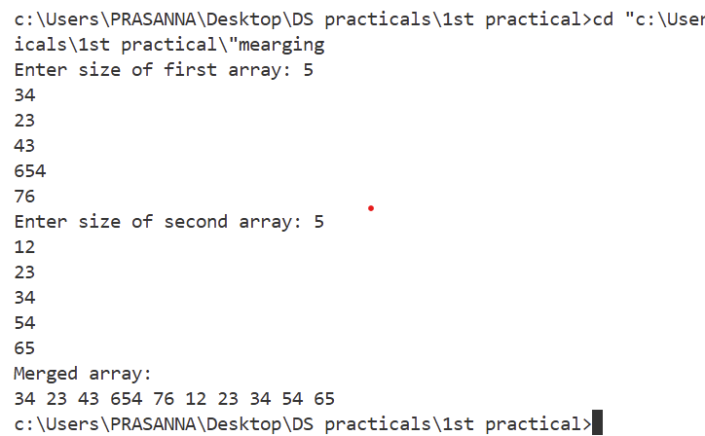
#include<stdio.h>
int main()
{
int a[50], b[50], c[100], n1, n2, i;
printf("Enter size of first array: ");
scanf("%d",&n1);
for(i=0;i<n1;i++)
scanf("%d",&a[i]);
printf("Enter size of second array: ");
scanf("%d",&n2);
for(i=0;i<n2;i++)
scanf("%d",&b[i]);
for(i=0;i<n1;i++)
c[i]=a[i];
for(i=0;i<n2;i++)
c[n1+i]=b[i];
printf("Merged array:\n");
for(i=0;i<n1+n2;i++)
printf("%d ",c[i]);
return 0;
}

7. Reversing Array
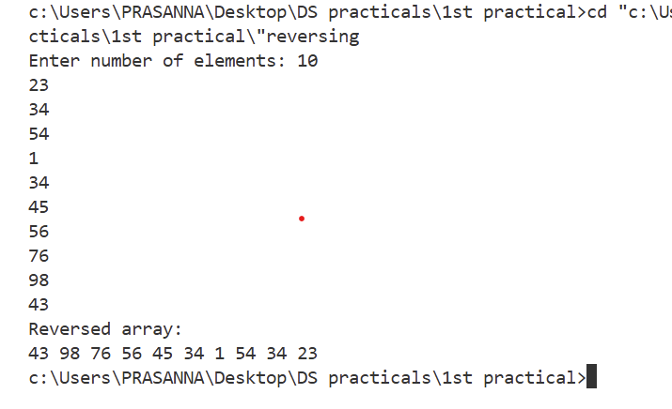
#include<stdio.h>
int main()
{
int arr[100], n, i;
printf("Enter number of elements: ");
scanf("%d",&n);
for(i=0;i<n;i++)
scanf("%d",&arr[i]);
printf("Reversed array:\n");
for(i=n-1;i>=0;i--)
printf("%d ",arr[i]);
return 0;
}

8. Copying Array
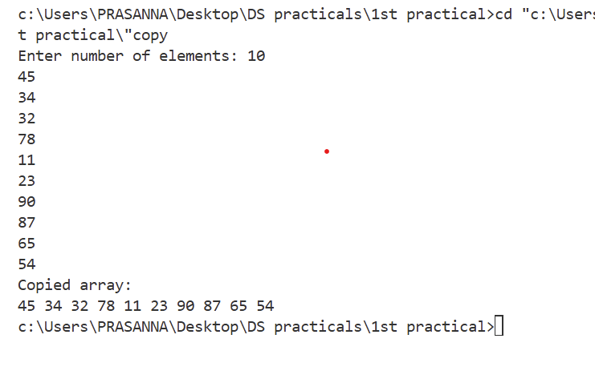
#include<stdio.h>
int main()
{
int a[100], b[100], n, i;
printf("Enter number of elements: ");
scanf("%d",&n);
for(i=0;i<n;i++)
scanf("%d",&a[i]);
for(i=0;i<n;i++)
b[i]=a[i];
printf("Copied array:\n");
for(i=0;i<n;i++)
printf("%d ",b[i]);
return 0;
}

9. Sum and Average
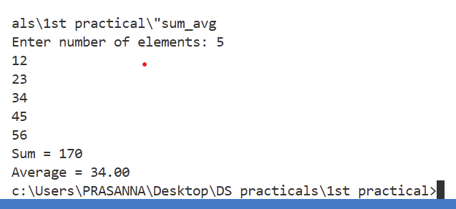
#include<stdio.h>
int main()
{
int arr[100], n, i, sum=0;
float avg;
printf("Enter number of elements: ");
scanf("%d",&n);
for(i=0;i<n;i++)
scanf("%d",&arr[i]);
for(i=0;i<n;i++)
sum=sum+arr[i];
avg = sum/n;
printf("Sum = %d\n",sum);
printf("Average = %.2f",avg);
return 0;
}

10. Maximum and Minimum
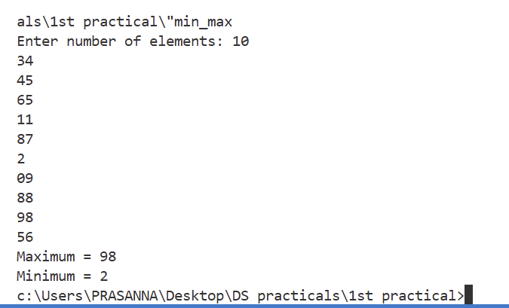
#include<stdio.h>
int main()
{
int arr[100], n, i, max, min;
printf("Enter number of elements: ");
scanf("%d",&n);
for(i=0;i<n;i++)
scanf("%d",&arr[i]);
max=min=arr[0];
for(i=1;i<n;i++)
{
if(arr[i]>max)
max=arr[i];
if(arr[i]<min)
min=arr[i];
}
printf("Maximum = %d\n",max);
printf("Minimum = %d",min);
return 0;
}

11. Second Largest Element
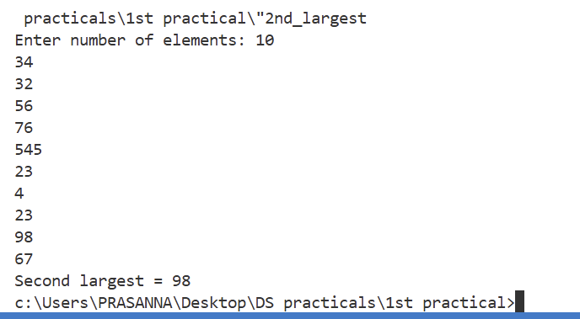
#include<stdio.h>
int main()
{
int arr[100], n, i, largest, second;
printf("Enter number of elements: ");
scanf("%d",&n);
for(i=0;i<n;i++)
scanf("%d",&arr[i]);
largest = second = arr[0];
for(i=1;i<n;i++)
{
if(arr[i]>largest)
{
second = largest;
largest = arr[i];
}
else if(arr[i]>second && arr[i]!=largest)
{
second = arr[i];
}
}
printf("Second largest = %d",second);
return 0;
}

12. Second Minimum Element
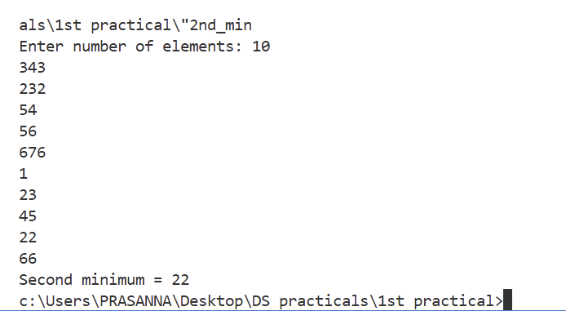
#include<stdio.h>
int main()
{
int arr[100], n, i, min, second;
printf("Enter number of elements: ");
scanf("%d",&n);
for(i=0;i<n;i++)
scanf("%d",&arr[i]);
min = second = arr[0];
for(i=1;i<n;i++)
{
if(arr[i]<min)
{
second = min;
min = arr[i];
}
else if(arr[i]<second && arr[i]!=min)
{
second = arr[i];
}
}
printf("Second minimum = %d",second);
return 0;
}

